Name- Ansari Mohd Saif
Roll No- 25AI22
Div - A
Experiment 2.1
Aim- Given an integer, , perform the following conditional actions:
● If is odd, print Weird
● If is even and in the inclusive range of to , print Not Weird
● If is even and in the inclusive range of to , print Weird
● If is even and greater than , print Not Weird
(https://www.hackerrank.com/challenges/java-if-else/problem)

Theory: Conditional Statements in Java (Weird / Not Weird)
This program is based on decision-making using conditional statements in Java. It checks whether a given integer satisfies certain conditions and prints either “Weird” or “Not Weird” accordingly.
🔹 Objective of the Program
The objective is to:
- Take an integer input from the user
- Apply conditional logic based on:
  - Odd or even nature
  - Specific number ranges
- Display the appropriate output
🔹 Concepts Used
1. Conditional Statements (if-else)
The program uses if-else statements to evaluate multiple conditions. These statements help the program make decisions based on the input value.
2. Modulus Operator (%)
The modulus operator is used to check whether a number is odd or even:
- If n % 2 != 0 → number is odd
- If n % 2 == 0 → number is even
🔹 Conditions Applied
Let the input number be n:
- If n is odd
- Print "Weird"
- If n is even and between 2 to 5 (inclusive)
- Print "Not Weird"
- If n is even and between 6 to 20 (inclusive)
- Print "Weird"
- If n is even and greater than 20
- Print "Not Weird"
🔹 Logic Flow
- The program first checks if the number is odd.
- If not, it checks if the number is even and falls within specific ranges.
- Based on these checks, it prints the corresponding output.
🔹 Example
Input (n) | Condition Met | Output
3 | Odd | Weird
4 | Even (2–5) | Not Weird
8 | Even (6–20) | Weird
22 | Even (>20) | Not Weird

🔹 Applications
- Decision-making in programs
- Input validation systems
- Logic building for competitive programming
🔹 Advantages
- Helps understand control flow in Java
- Improves logical thinking and problem-solving skills
- Foundation for advanced programming concepts

Code-
import java.util.Scanner;

public class WeirdNotWeird {
public static void main(String[] args) {

Scanner sc = new Scanner(System.in);

System.out.print("Enter a number: ");
int n = sc.nextInt();

if (n % 2 != 0) {
System.out.println("Weird");
} else {
if (n >= 2 && n <= 5) {
System.out.println("Not Weird");
} else if (n >= 6 && n <= 20) {
System.out.println("Weird");
} else {
System.out.println("Not Weird");
}
}

sc.close();
}
}

Output-
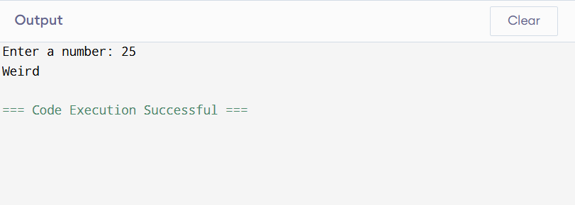

Conclusion-
This problem is a basic yet important example of using if-else conditions in Java. It helps beginners understand how programs can make decisions based on input and execute different outputs accordingly.

Experiment 2.2
Aim-Write a Java program that accepts the student's name, roll
number, and marks in five subjects, each out of 100. The
program should validate that all entered marks are between 0 and
100. Calculate total marks (sum of all subjects), Average marks
and Percentage. Assign an appropriate grade based on the average marks and add a remark based on the grade.

Theory: Student Marks, Percentage & Grade Calculation in Java
This program is designed to accept student details and marks, validate the input, and calculate total marks, average, percentage, grade, and remarks. It demonstrates important Java concepts like input handling, validation, loops, and conditional statements.
🔹 Objective of the Program
- To accept:
  - Student Name
  - Roll Number
  - Marks in 5 subjects (out of 100)
- To validate marks (must be between 0 and 100)
- To calculate:
  - Total Marks
  - Average Marks
  - Percentage
- To assign:
  - Grade
  - Remark
🔹 Concepts Used
1. Scanner Class
Used to take input from the user:
- nextLine() → for name
- nextInt() → for roll number & marks
2. Loop (for loop)
A loop is used to input marks for 5 subjects and calculate the total.
3. Input Validation
Each mark is checked:
Marks must be between 0 and 100
If invalid, the user is asked to re-enter the marks.
4. Calculations
- Total Marks = Sum of all 5 subjects
- Average = Total ÷ 5
- Percentage = Same as average (since each subject is out of 100)
5. Grade Assignment
Average (%) | Grade | Remark
≥ 90 | A+ | Excellent
≥ 75 | A | Very Good
≥ 60 | B | Good
≥ 50 | C | Average
< 50 | F | Fail

🔹 Working of the Program
- Program starts from main()
- Takes student details
- Accepts marks with validation
- Calculates total, average, percentage
- Determines grade and remark
- Displays all results
🔹 Advantages
- Ensures valid input
- Demonstrates real-world grading system
- Improves logic-building skills

Code-
import java.util.Scanner;

public class StudentResult {
public static void main(String[] args) {

Scanner sc = new Scanner(System.in);

// Input student details
System.out.print("Enter Student Name: ");
String name = sc.nextLine();

System.out.print("Enter Roll Number: ");
int roll = sc.nextInt();

int total = 0;
int marks;

// Input marks with validation
for (int i = 1; i <= 5; i++) {
while (true) {
System.out.print("Enter marks for subject " + i + ": ");
marks = sc.nextInt();

if (marks >= 0 && marks <= 100) {
total += marks;
break;
} else {
System.out.println("Invalid marks! Enter between 0 and 100.");
}
}
}

// Calculations
double average = total / 5.0;
double percentage = average;

String grade, remark;

// Grade logic
if (average >= 90) {
grade = "A+";
remark = "Excellent";
} else if (average >= 75) {
grade = "A";
remark = "Very Good";
} else if (average >= 60) {
grade = "B";
remark = "Good";
} else if (average >= 50) {
grade = "C";
remark = "Average";
} else {
grade = "F";
remark = "Fail";
}

// Output
System.out.println("\n--- Student Result ---");
System.out.println("Name: " + name);
System.out.println("Roll No: " + roll);
System.out.println("Total Marks: " + total);
System.out.println("Average: " + average);
System.out.println("Percentage: " + percentage + "%");
System.out.println("Grade: " + grade);
System.out.println("Remark: " + remark);

sc.close();
}
}
Output-
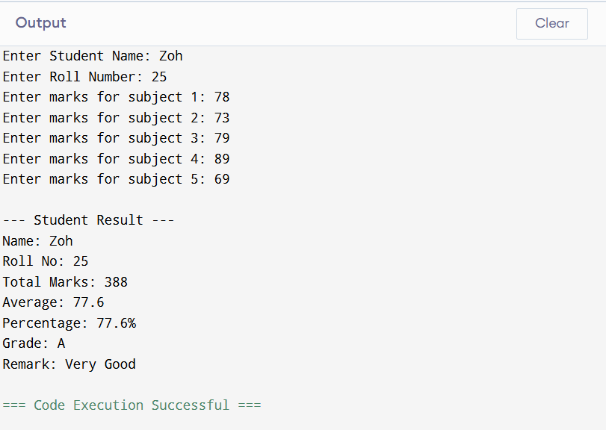
Conclusion-
This program is a practical example of how Java can be used in education systems to automate result processing. It combines input handling, validation, and decision-making effectively.

Experiment 2.3
Aim-Print number pattern using loops. Use nested loops to generate a triangle number pattern, applying conditional checks.

Theory: Number Pattern Printing using Nested Loops in Java
This program demonstrates how to print number patterns using nested loops and conditional statements in Java. Pattern printing is an important concept for beginners to understand loop control, logic building, and output formatting.
🔹 Objective of the Program
- To generate a triangle number pattern
- To use nested loops for row and column control
- To apply conditions for printing numbers in a specific format
🔹 Concepts Used
1. Loops
- Outer Loop → controls the number of rows
- Inner Loop → controls the number of columns (numbers in each row)
2. Nested Loops
A loop inside another loop is called a nested loop.
It helps in creating patterns (triangle, pyramid, etc.).
3. Conditional Statements
Conditions (if statements) are used to:
- Decide what to print (number or space)
- Control the pattern structure
🔹 Example Pattern
1
1 2
1 2 3
1 2 3 4
1 2 3 4 5
🔹 Logic Explanation
- The outer loop runs from 1 to n (number of rows).
- The inner loop runs from 1 to current row number.
- Each iteration prints numbers in increasing order.
- After each row, a new line is printed.
🔹 Working of the Program
- User enters the number of rows
- Outer loop controls rows
- Inner loop prints numbers up to the current row
- Pattern is displayed in triangular form
🔹 Advantages
- Improves logical thinking
- Strengthens understanding of loops
- Useful for coding interviews and exams

Code-
import java.util.Scanner;

public class NumberPattern {
public static void main(String[] args) {

Scanner sc = new Scanner(System.in);

System.out.print("Enter number of rows: ");
int n = sc.nextInt();

// Outer loop for rows
for (int i = 1; i <= n; i++) {

// Inner loop for numbers
for (int j = 1; j <= i; j++) {

// Condition (can be modified for different patterns)
if (j <= i) {
System.out.print(j + " ");
}
}

// Move to next line after each row
System.out.println();
}

sc.close();
}
}

Output-
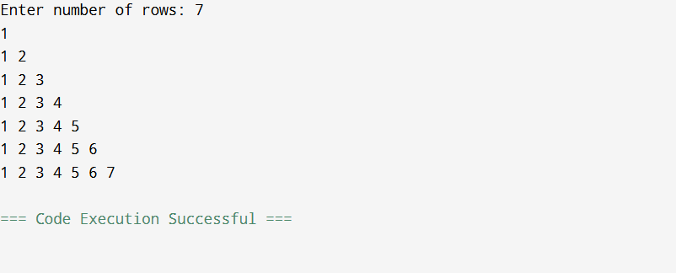

Conclusion-
Pattern printing using nested loops is a fundamental concept in Java programming. It helps in building strong problem-solving skills and understanding how loops and conditions work together.

Expeiment 2.4
Aim-Test your Learning:
Java Loops: Read integer N (2–20) and print its first ten multiples.
(https://www.hackerrank.com/challenges/java-loops-i/problem)
Here’s the theory + Java code for your Java Loops (Multiples) problem:
Theory: Java Loops – Printing Multiples
This program is designed to read an integer N and print its first 10 multiples. It demonstrates the use of loops and iteration in Java.
🔹 Objective of the Program
- To take an integer input N (between 2 and 20)
- To generate and display the first 10 multiples of N
- To understand how loops work in Java
🔹 Concepts Used
1. Loop (for loop)
A for loop is used to repeat a set of statements multiple times.
- It is ideal when the number of iterations is known (here, 10 times).
Syntax:
for(initialization; condition; increment/decrement)
2. Iteration
The loop runs from 1 to 10, and in each iteration:
- The current value is multiplied with N
- The result is printed
3. Input Handling
The program uses the Scanner class to take input from the user.
🔹 Logic of the Program
- Read integer N
- Run a loop from i = 1 to 10
- In each iteration:
- Result = N × i
- Print in formatted form:
- N x i = Result
🔹 Example
For input:
N = 2
Output:
2 x 1 = 2
2 x 2 = 4
...
2 x 10 = 20
🔹 Applications
- Learning multiplication tables
- Understanding loops and repetition
- Useful in basic mathematical programs
🔹 Advantages
- Simple and efficient
- Improves understanding of loops and iteration
- Builds strong programming basics

Code-
import java.util.Scanner;

public class Multiples {
public static void main(String[] args) {

Scanner sc = new Scanner(System.in);

System.out.print("Enter a number (2–20): ");
int n = sc.nextInt();

for (int i = 1; i <= 10; i++) {
System.out.println(n + " x " + i + " = " + (n * i));
}

sc.close();
}
}

Output-
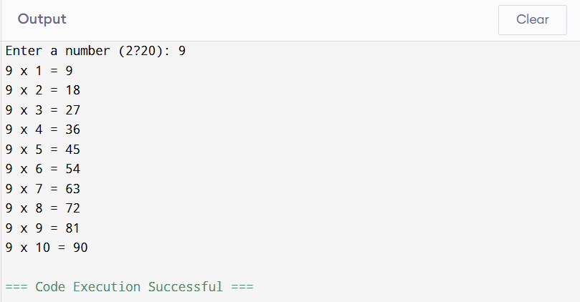
Conclusion-
This program is a basic example of using loops in Java to perform repeated calculations. It helps beginners understand how iteration works and how to structure repetitive tasks efficiently.

